SickOS 1.2

- Netdiscover is used to identify the target IP (10.10.10.9)
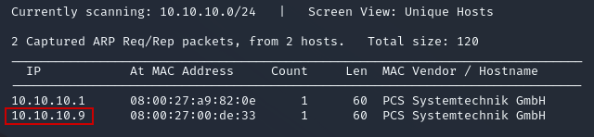

- Use nmap to scan the target IP
- Finding 2 open ports, a http and ssh port
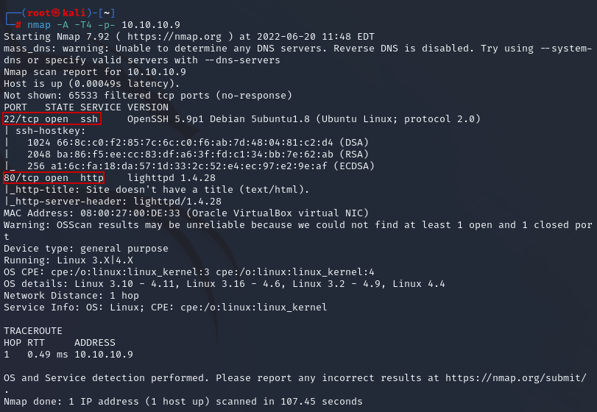

- Seeing port 80 open hints it might be a web application. This is the result:


- Looking at the source code reveals nothing of benefit
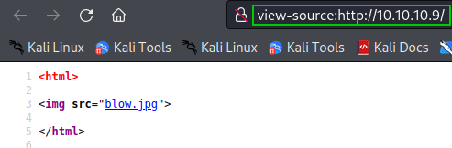

- Using “DirBuster”, we can see the various directories sickOS contains
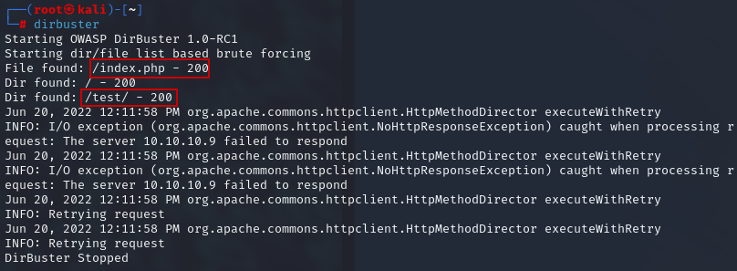

- Looking at /test/ shows a place to possibly upload something malicious
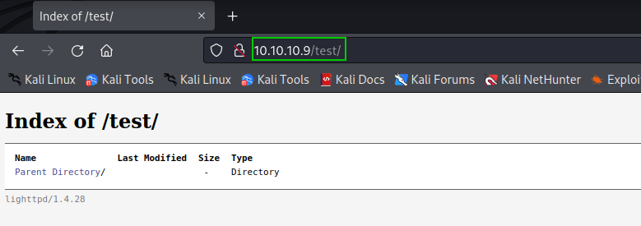

- Using the “curl’ command, we are able to see the “PUT” command is available to use. The curl command is used to transfer data to or from a server
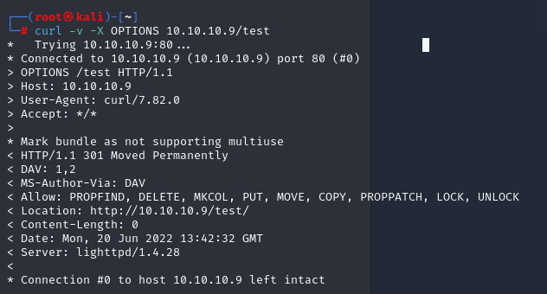

- Using the PUT command alongside curl, we are able to upload the php file to the /test/ page seen earlier
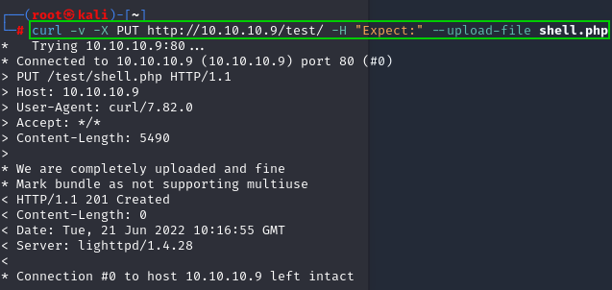
- Checking the /test/ page we can see the upload was successful
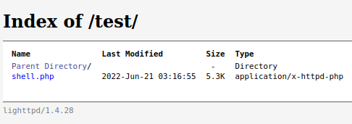

- On port 443, a listener is set up.
- 443 was chosen because both ports 444 and 4444 were blocked
- Using python, a bash shell is spawned
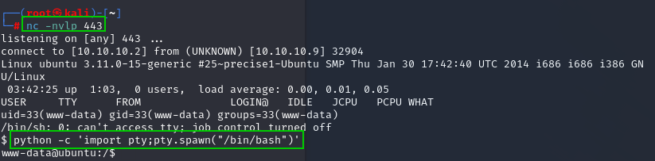

- While navigating through the file system, chkrootkit is found in the /etc/cron.daily directory
- After some research, this version of chkrootkit has a known local privilege escalation exploit
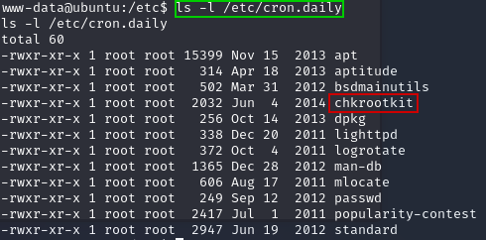

- Manual exploitation of the chkrootkit entails creating a file named “update” and within that file is a command that removes the need for a sudoers password, basically allowing us to change into root user without a password
- The file is run once chron.daily runs, which after a short wait it completed
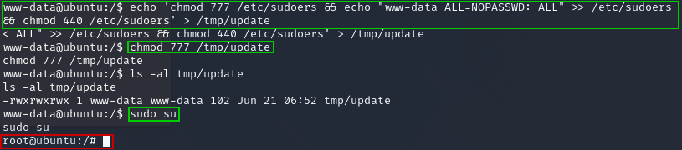

- Navigating through root, a .txt file is found which turns out to be the root flag
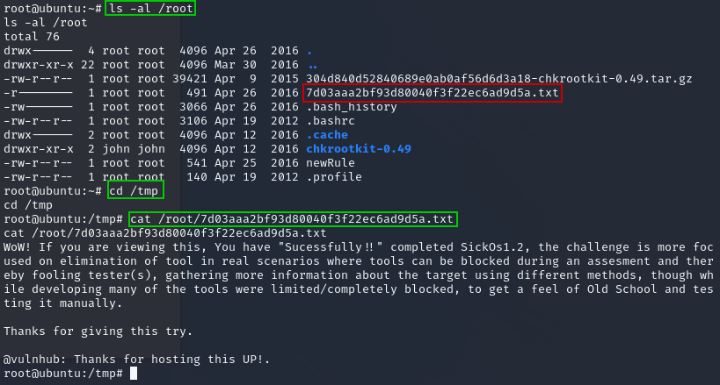
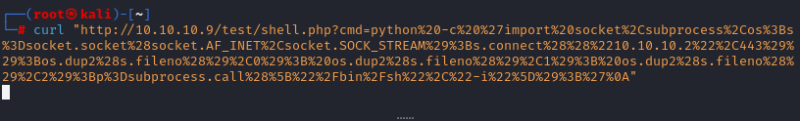
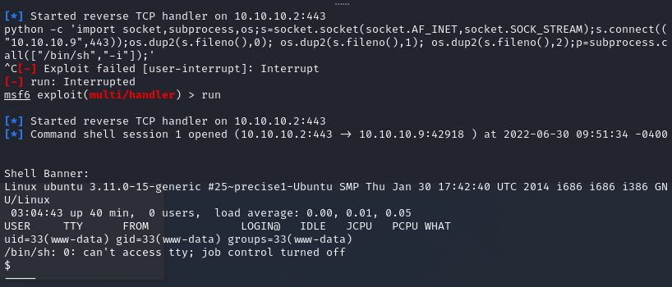

- In order to get the flag on my machine, I renamed and moved the file to the /test/ directory
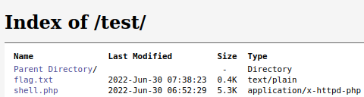

- From there, I used “wget” to connect to the web page and download the flag file
